IIC Calendar Activity
A Overall Report on “Engineers’ Day Celebrations – Quiz Competition” On 15-09-2026.
Title of The Event |  | Engineers’ Day Celebrations – Quiz Competition
Event Convener/ Coordinator & Details |  | Prof. D.Venkatesh, HOD & Associate Professor,  Department of Civil Engineering,  Narsimha Reddy Engineering College.
Program Type* Please mention any one of the Given Below.  Level 2 - Workshop |  | Level 2 - Quiz
Program Theme * Please mention any one of the Given Below.  1.IPR & Technology Transfer |  | Engineers’ Day Celebrations – Technical Knowledge, Innovation & Teamwork
Start Date :  End Date :  Duration of the activity : |  | 15-09-2026  15-09-2026  01.00 PM to 04.00 PM
Mode of Session |  | Offline
Number of Student Participants * |  | 100
Objective of The Event |  | The primary objective of the Engineers’ Day Quiz Competition was to commemorate the birth anniversary of Sir M. Visvesvaraya and promote technical knowledge, analytical thinking and teamwork among Civil Engineering students. The programme aimed to:  - Celebrate Engineers’ Day by honoring the contributions of Sir M. Visvesvaraya.  - Enhance students’ technical knowledge in Civil Engineering.  - Encourage analytical thinking and problem-solving abilities.  - Promote healthy academic competition and teamwork.  - Improve awareness of engineering innovations and current developments.  - Motivate students to participate in technical and professional activities.
Outcome workshop/ Benefit in terms of learning/Skill/Knowledge obtained |  | 1. Learning Benefits  - Improved understanding of core Civil Engineering concepts.  - Increased awareness of famous engineers and engineering achievements.  - Better knowledge of surveying, transportation, structural and environmental engineering.  - Enhanced awareness of engineering applications and technological developments.  2. Skill Development  - Critical thinking and logical reasoning.  - Teamwork and collaborative decision-making.  - Communication and presentation skills.  - Time management during competitive events.  - Quick decision-making and problem-solving.  3. Knowledge Gained  - Engineering history and the legacy of Sir M. Visvesvaraya.  - Practical application of Civil Engineering fundamentals.  - Awareness of surveying, structures, transportation and environmental engineering.  - Importance of technical competitions in professional development.
Brief Report: |  | The Department of Civil Engineering, Narsimha Reddy Engineering College (Autonomous), organized an Engineers’ Day Celebration – Civil Engineering Quiz Competition on 15 September 2026 at the MT Block Seminar Hall.  The programme was organized to commemorate Engineers’ Day and to honor the remarkable contributions of Bharat Ratna Sir M. Visvesvaraya, whose contributions to engineering and nation-building continue to inspire generations of engineers.  The programme commenced with an introduction highlighting the importance of Engineers’ Day and the contributions of Sir M. Visvesvaraya. Faculty members emphasized the significance of technical knowledge, innovation, problem-solving abilities, teamwork and ethical engineering practices.  The Civil Engineering Quiz Competition was conducted through multiple rounds covering various areas of engineering knowledge, including:  - General Engineering  - Civil Engineering Fundamentals  - Surveying and GIS  - Structural Engineering  - Transportation Engineering  - Environmental Engineering  - Rapid Fire Round  Students participated enthusiastically in teams and demonstrated their technical knowledge, analytical thinking, quick decision-making and teamwork throughout the competition.  The competition provided students with an opportunity to revise and apply their knowledge in a competitive environment. It also encouraged students to improve their communication skills and develop confidence in participating in technical activities.  The programme concluded with the announcement of the winners, distribution of prizes and certificates, and a vote of thanks. The event successfully promoted technical learning and a spirit of healthy academic competition among the students.
Learning Outcomes |  | After participating in the quiz competition, students:  - Strengthened their technical aptitude in Civil Engineering.  - Enhanced their confidence in competitive technical events.  - Developed teamwork and leadership qualities.  - Improved analytical and logical thinking abilities.  - Enhanced their awareness of engineering developments.  - Developed interest in continuous learning and professional development.
Conclusion |  | The Engineers’ Day Celebrations – Civil Engineering Quiz Competition provided an engaging platform for students to demonstrate their technical knowledge while commemorating the legacy of Sir M. Visvesvaraya.  The event promoted technical learning, analytical thinking, teamwork and healthy academic competition among Civil Engineering students. It also encouraged students to participate actively in technical and professional activities and inspired them towards continuous learning and engineering excellence.
Poster/ Brochure of the Event |  | 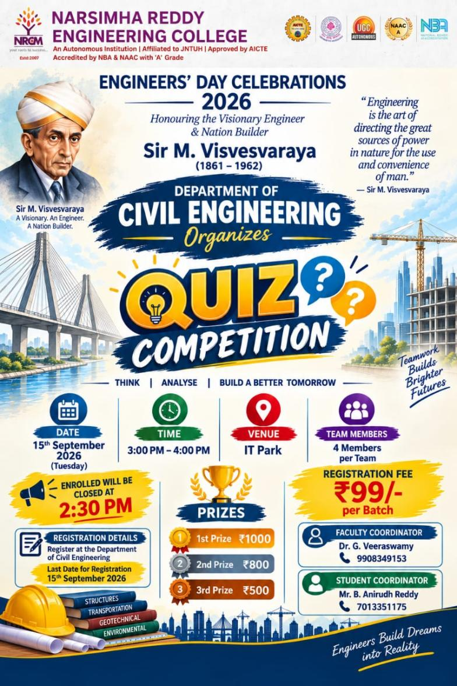
Event Photograph 1 |  | 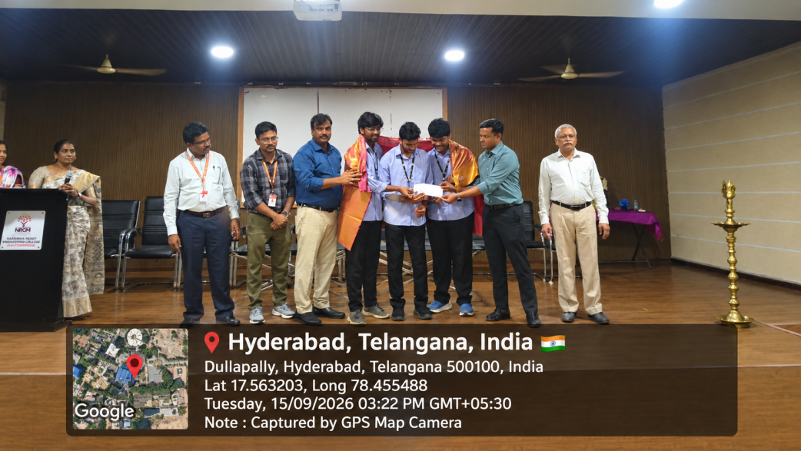
Event Photograph 2 |  | 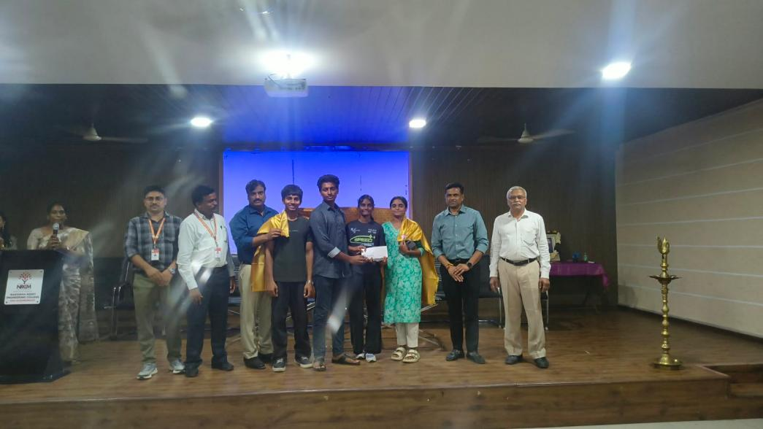
Event Photograph 2 |  | 